Learners’ Survey
Academic Year 2025-2026
IGCSE Boys - College Campus
Dated: 24, 25, & 26 September, 2025
IG-II Mars - Boys
Total Reponses: 25
Q#1: Which teachers encourage you the most to ask questions about the topics being studied and are happy to answer them? *You may select as many options as you like.
Name | Responses | Percentage
Ms. Farah Imran - History | 15 | 15%
Mr. Amir Mukhtiar- Chemistry | 14 | 14%
Ms. Adeeba Tariq - Maths | 13 | 13%
Mr. Habib ur Rehman- Islamiyat | 13 | 13%
Ms. Shazia Lashari - Urdu | 11 | 11%
Mr. Ali Javed - Physics | 11 | 11%
Ms. Zainab Afridi - English | 9 | 9%
Mr. Adnan Zafar - Computer Science | 7 | 7%
Mr. Amir Saleem - Geography | 7 | 7%
None of the above | 1 | 1%

Q#2: Which teachers report late for the class? * (You may select as many options as you like.)*
Name | Responses | Percentage
None of the above | 10 | 31%
Mr. Amir Mukhtiar- Chemistry | 9 | 28%
Mr. Amir Saleem - Geography | 6 | 19%
Ms. Shazia Lashari - Urdu | 3 | 9%
Ms. Zainab Afridi - English | 2 | 6%
Mr. Adnan Zafar - Computer Science | 2 | 6%
Ms. Adeeba Tariq - Maths | 0 | 0%
Mr. Ali Javed - Physics | 0 | 0%
Mr. Habib ur Rehman- Islamiyat | 0 | 0%
Ms. Farah Imran - History | 0 | 0%

Q#3: Which teachers conclude their classes before the allotted time? * (You may select as many options as you like.)
Name | Responses | Percentage
None of the above | 16 | 52%
Mr. Amir Saleem - Geography | 4 | 13%
Ms. Shazia Lashari - Urdu | 2 | 6%
Ms. Adeeba Tariq - Maths | 2 | 6%
Mr. Adnan Zafar - Computer Science | 2 | 6%
Mr. Ali Javed - Physics | 2 | 6%
Mr. Amir Mukhtiar- Chemistry | 1 | 3%
Mr. Habib ur Rehman- Islamiyat | 1 | 3%
Ms. Farah Imran - History | 1 | 3%
Ms. Zainab Afridi - English | 0 | 0%

Q#4: Which teachers indulge in irrelevant discussions. * (You may select as many options as you like.)
Name | Responses | Percentage
None of the above | 16 | 55%
Mr. Ali Javed - Physics | 4 | 14%
Mr. Amir Mukhtiar- Chemistry | 3 | 10%
Mr. Amir Saleem - Geography | 3 | 10%
Mr. Adnan Zafar - Computer Science | 2 | 7%
Ms. Shazia Lashari - Urdu | 1 | 3%
Ms. Zainab Afridi - English | 0 | 0%
Ms. Adeeba Tariq - Maths | 0 | 0%
Mr. Habib ur Rehman- Islamiyat | 0 | 0%
Ms. Farah Imran - History | 0 | 0%

Q#5: Which teachers use cell phones in their classes? * (You may select as many options as you like.)
Name | Responses | Percentage
None of the above | 18 | 72%
Ms. Shazia Lashari - Urdu | 2 | 8%
Ms. Adeeba Tariq - Maths | 2 | 8%
Mr. Adnan Zafar - Computer Science | 2 | 8%
Ms. Zainab Afridi - English | 1 | 4%
Mr. Amir Mukhtiar- Chemistry | 0 | 0%
Mr. Ali Javed - Physics | 0 | 0%
Mr. Habib ur Rehman- Islamiyat | 0 | 0%
Mr. Amir Saleem - Geography | 0 | 0%
Ms. Farah Imran - History | 0 | 0%

Q#6. Which teacher asks you to take paid tuition from him/her in the evening to get an A* or a good grade?
Name | Responses | Percentage
None of the above | 18 | 72%
Ms. Shazia Lashari - Urdu | 4 | 16%
Mr. Amir Saleem - Geography | 3 | 12%
Ms. Zainab Afridi - English | 0 | 0%
Ms. Adeeba Tariq - Maths | 0 | 0%
Mr. Amir Mukhtiar- Chemistry | 0 | 0%
Mr. Adnan Zafar - Computer Science | 0 | 0%
Mr. Ali Javed - Physics | 0 | 0%
Mr. Habib ur Rehman- Islamiyat | 0 | 0%
Ms. Farah Imran - History | 0 | 0%

Q#7. Which subject do you find most challenging?
Name | Responses | Percentage
Mr. Amir Mukhtiar- Chemistry | 16 | 41%
Ms. Shazia Lashari - Urdu | 7 | 18%
None of the above | 4 | 10%
Mr. Adnan Zafar - Computer Science | 3 | 8%
Mr. Ali Javed - Physics | 3 | 8%
Ms. Farah Imran - History | 3 | 8%
Ms. Zainab Afridi - English | 1 | 3%
Mr. Habib ur Rehman- Islamiyat | 1 | 3%
Mr. Amir Saleem - Geography | 1 | 3%
Ms. Adeeba Tariq - Maths | 0 | 0%

Q#8. How would you rate the teacher’s overall performance?
Name | Ranking
Mr. Ali Javed - Physics | 1
Mr. Habib ur Rehman- Islamiyat | 2
Ms. Farah Imran - History | 3
Mr. Amir Mukhtiar- Chemistry | 4
Ms. Zainab Afridi - English | 5
Mr. Amir Saleem - Geography | 6
Ms. Adeeba Tariq - Maths | 7
Mr. Adnan Zafar - Computer Science | 8
Ms. Shazia Lashari - Urdu | 9

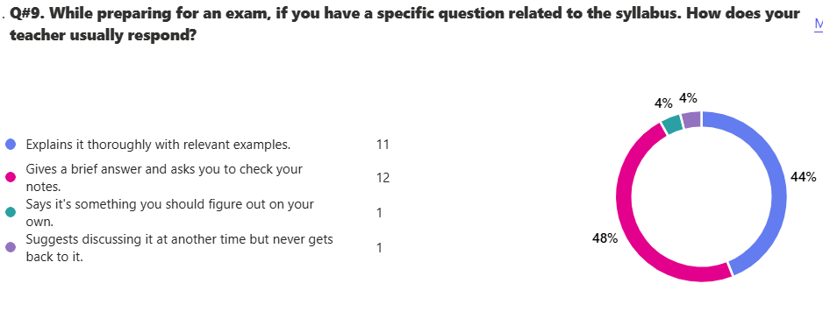

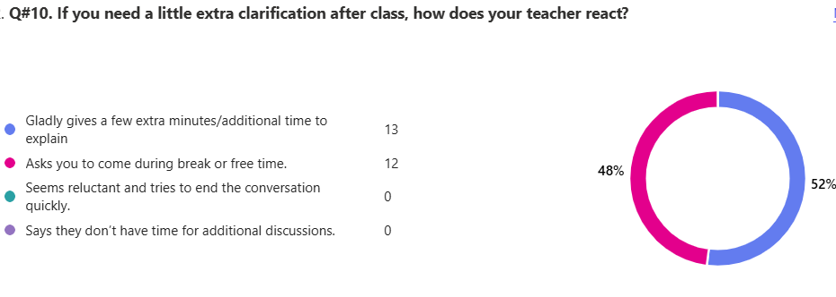
13. Any feedback that you would like to share with Board of Directors.
23 responses

ID | Responses
1 | Sir amir saleem talks about other teachers in the class and he says that he is the best pak study teacher.
2 | NOTHING
3 | sir amir saleem says he is the best teacher of pak stydies and says all other teacher are not good
4 | No response as of now.
5 | Pata nahi twyn
6 | Nothing
7 | nothing
8 | W_frfr
9 | please increase our sports periods in 1 week we only have it once and its unfair for us to have games onces
10 | please change mam shazia lashari
11 | Sir Amir takes alot of time just changing seats for no reason and scolds the one who doesnot even do anything
12 | Kindly get the table tennis tables fixed in time. they were broken for the entire past year and now broken again. Also please give punishments to those kids who are unserious in studies in our class and dont let quality teachers like sir amir saleem and sir habib teach properly which prevents the ones who are serious in studies in performing well due to a lot of noise in class and constant chattering of children
13 | Please improve the cameras as many students fight during break
14 | sir amir mukhtiar comes to the class and drags all the seats haphazardly WHILE WE'RE SITTING ON THEM and he changes the arrangement of the whole class; the floor managers scold us for it in break. this ruins the mood of the whole class and wastes alot of time and also damages water bottles that are on the ground because he doesn't look before dragging someone's seat.
15 | please renew the tables of table tennis and other essentials
16 | Most of the teachers give me thorough answers to my question, but history and urdu ma'am take time to respond. While sir Amir Saleem refer to go through his notes from his website, but overall i love his teaching style and understand him
17 | the number of games should be increased as only one day is dedicated to games
18 | There are many bullies in the class who become innocent infront of teachers and indulge in physical bullying vulgur language.Dear directors I suggest you to keep this class under observation and take strict measures against bullies
19 | more games during breaks
20 | nothing much this school is really great and the people are really friendly and ofc the teachers are really nice
21 | sir ali javed,maam farah ,sir amir saleem ,maam shazia and sir habib are the best teachers.They always cooperate with the students and clear all the problems.
22 | The washrooms are out of handwash a lot of the time and it does not get added, the stalls inside are too conjusted and the door height is very LOW which is a huge problem for students above 5'10. Moreover, i am not sure if were having a welcome but it would be really nice if the welcome happened at the start of the term - not the end of it. Furthermore, another huge problem students like me face is that there are a LOT of mosquitos. Another thing i would like to add is that even though sir habib is one o fthe best islamiat teachers i have ever seen he should be a little more strict and should speak louder. It would be nice if we could rank more than one teacher as the first one. The canteen is also very expensive and sometimes the food i very unhygienic
23 | Dear Directors, my class has some really good teachers but due to some children we can not really understand that well as some of the children create noise. Even in break or free time children do physical and verbal bullying to each other which is not good and even when the teachers come they blame it on someone else. Some of the children also use vulgar language. I suggest the Board of Directors to keep my class in special observation themselves to understand the intensity of this situation.

IG-II Neptune - Boys
Total Reponses: 25
Q#1: Which teachers encourage you the most to ask questions about the topics being studied and are happy to answer them? *You may select as many options as you like.
Name | Responses | Percentage
Ms. Tazeen Zahra - Physics | 14 | 22%
Mr. Mohsin Saleem – Chemistry | 12 | 19%
Mr. Khawaja Zahid Hussain - History | 10 | 16%
Mr. Najam ul Hassan - Maths | 8 | 13%
Mr. Danyal Tariq - Geography | 6 | 10%
Mr. Irfan Sajjad Alvi - Islamiyat | 4 | 6%
Ms. Fauzia Tabassum - Urdu | 3 | 5%
Ms. Bushra Abbas - English | 2 | 3%
Mr. Adnan Zafar - Computer Science | 2 | 3%
None of the above | 2 | 3%

Q#2: Which teachers report late for the class? * (You may select as many options as you like.)*
Name | Responses | Percentage
None of the above | 13 | 39%
Ms. Bushra Abbas - English | 7 | 21%
Ms. Fauzia Tabassum - Urdu | 5 | 15%
Ms. Tazeen Zahra - Physics | 3 | 9%
Mr. Irfan Sajjad Alvi - Islamiyat | 2 | 6%
Mr. Danyal Tariq - Geography | 2 | 6%
Mr. Mohsin Saleem – Chemistry | 1 | 3%
Mr. Najam ul Hassan - Maths | 0 | 0%
Mr. Adnan Zafar - Computer Science | 0 | 0%
Mr. Khawaja Zahid Hussain - History | 0 | 0%

Q#3: Which teachers conclude their classes before the allotted time? * (You may select as many options as you like.)
Name | Responses | Percentage
None of the above | 17 | 61%
Ms. Bushra Abbas - English | 3 | 11%
Ms. Fauzia Tabassum - Urdu | 3 | 11%
Mr. Mohsin Saleem – Chemistry | 2 | 7%
Mr. Danyal Tariq - Geography | 2 | 7%
Mr. Khawaja Zahid Hussain - History | 1 | 4%
Mr. Najam ul Hassan - Maths | 0 | 0%
Mr. Adnan Zafar - Computer Science | 0 | 0%
Ms. Tazeen Zahra - Physics | 0 | 0%
Mr. Irfan Sajjad Alvi - Islamiyat | 0 | 0%

Q#4: Which teachers indulge in irrelevant discussions. * (You may select as many options as you like.)
Name | Responses | Percentage
None of the above | 11 | 37%
Ms. Bushra Abbas - English | 5 | 17%
Ms. Fauzia Tabassum - Urdu | 5 | 17%
Mr. Mohsin Saleem – Chemistry | 2 | 7%
Ms. Tazeen Zahra - Physics | 2 | 7%
Mr. Irfan Sajjad Alvi - Islamiyat | 2 | 7%
Mr. Khawaja Zahid Hussain - History | 2 | 7%
Mr. Danyal Tariq - Geography | 1 | 3%
Mr. Najam ul Hassan - Maths | 0 | 0%
Mr. Adnan Zafar - Computer Science | 0 | 0%

Q#5: Which teachers use cell phones in their classes? * (You may select as many options as you like.)
Name | Responses | Percentage
None of the above | 21 | 60%
Mr. Danyal Tariq - Geography | 5 | 14%
Ms. Bushra Abbas - English | 2 | 6%
Ms. Fauzia Tabassum - Urdu | 1 | 3%
Mr. Najam ul Hassan - Maths | 1 | 3%
Mr. Mohsin Saleem – Chemistry | 1 | 3%
Mr. Adnan Zafar - Computer Science | 1 | 3%
Ms. Tazeen Zahra - Physics | 1 | 3%
Mr. Irfan Sajjad Alvi - Islamiyat | 1 | 3%
Mr. Khawaja Zahid Hussain - History | 1 | 3%

Q#6. Which teacher asks you to take paid tuition from him/her in the evening to get an A* or a good grade?
Name | Responses | Percentage
None of the above | 23 | 92%
Ms. Fauzia Tabassum - Urdu | 2 | 8%
Ms. Bushra Abbas - English | 0 | 0%
Mr. Najam ul Hassan - Maths | 0 | 0%
Mr. Mohsin Saleem – Chemistry | 0 | 0%
Mr. Adnan Zafar - Computer Science | 0 | 0%
Ms. Tazeen Zahra - Physics | 0 | 0%
Mr. Irfan Sajjad Alvi - Islamiyat | 0 | 0%
Mr. Danyal Tariq - Geography | 0 | 0%
Mr. Khawaja Zahid Hussain - History | 0 | 0%

Q#7. Which subject do you find most challenging?
Name | Responses | Percentage
Mr. Najam ul Hassan - Maths | 8 | 21%
Mr. Mohsin Saleem – Chemistry | 8 | 21%
Ms. Bushra Abbas - English | 6 | 16%
Mr. Irfan Sajjad Alvi - Islamiyat | 5 | 13%
Ms. Fauzia Tabassum - Urdu | 3 | 8%
Ms. Tazeen Zahra - Physics | 3 | 8%
Mr. Adnan Zafar - Computer Science | 2 | 5%
Mr. Khawaja Zahid Hussain - History | 2 | 5%
None of the above | 1 | 3%
Mr. Danyal Tariq - Geography | 0 | 0%

Q#8. How would you rate the teacher’s overall performance?
Name | Ranking
Mr. Mohsin Saleem – Chemistry | 1
Mr. Khawaja Zahid Hussain - History | 2
Mr. Najam ul Hassan - Maths | 3
Mr. Danyal Tariq - Geography | 4
Ms. Tazeen Zahra - Physics | 5
Mr. Adnan Zafar - Computer Science | 6
Mr. Irfan Sajjad Alvi - Islamiyat | 7
Ms. Bushra Abbas - English | 8
Ms. Fauzia Tabassum - Urdu | 9

13. Any feedback that you would like to share with Board of Directors.
7 responses
ID | Responses
1 | please change the AC in our class
2 | P.S Dont take pak.studies or urdu
3 | nah yall good
4 | All teachers are amazing and the test that are being conducted on weekly bases have helped alot to prepare for monthly exam
5 | MATHS CLASS SHOULD BE HEID IN FIRST 5 PERIODS
6 | The Canteen situation needs to be looked after, the canteen workers are extremely unhygienic and dont use proper cooking attire, which is very concerning. Warm Regards, Ayaan Khalid
7 | Improve your maths faculty.

IG-II Venus - Boys
Total Reponses: 19
Q#1: Which teachers encourage you the most to ask questions about the topics being studied and are happy to answer them? *You may select as many options as you like.
Name | Responses | Percentage
Ms. Ayesha Khalid - Maths | 15 | 19%
Ms. Nida Asim - Physics | 13 | 16%
Ms. Durdana Sami - History | 11 | 14%
Ms. Ghazal Shariq - Chemistry | 10 | 12%
Ms. Farheen Sajid - Biology | 9 | 11%
Mr. Irfan Sajjad Alvi - Islamiyat | 8 | 10%
Ms. Bushra Abbas - English | 6 | 7%
Ms. Rabia Nasir - Geography | 6 | 7%
Ms. Qudsia Shaheen – Urdu | 3 | 4%
None of the above | 0 | 0%

Q#2: Which teachers report late for the class? * (You may select as many options as you like.)*
Name | Responses | Percentage
None of the above | 7 | 28%
Ms. Farheen Sajid - Biology | 4 | 16%
Ms. Nida Asim - Physics | 4 | 16%
Ms. Rabia Nasir - Geography | 4 | 16%
Ms. Ghazal Shariq - Chemistry | 3 | 12%
Ms. Bushra Abbas - English | 1 | 4%
Ms. Qudsia Shaheen – Urdu | 1 | 4%
Ms. Durdana Sami - History | 1 | 4%
Ms. Ayesha Khalid - Maths | 0 | 0%
Mr. Irfan Sajjad Alvi - Islamiyat | 0 | 0%

Q#3: Which teachers conclude their classes before the allotted time? * (You may select as many options as you like.)
Name | Responses | Percentage
None of the above | 14 | 56%
Ms. Rabia Nasir - Geography | 3 | 12%
Ms. Farheen Sajid - Biology | 2 | 8%
Ms. Nida Asim - Physics | 2 | 8%
Mr. Irfan Sajjad Alvi - Islamiyat | 2 | 8%
Ms. Qudsia Shaheen – Urdu | 1 | 4%
Ms. Ghazal Shariq - Chemistry | 1 | 4%
Ms. Bushra Abbas - English | 0 | 0%
Ms. Ayesha Khalid - Maths | 0 | 0%
Ms. Durdana Sami - History | 0 | 0%

Q#4: Which teachers indulge in irrelevant discussions. * (You may select as many options as you like.)
Name | Responses | Percentage
None of the above | 7 | 27%
Ms. Nida Asim - Physics | 5 | 19%
Mr. Irfan Sajjad Alvi - Islamiyat | 5 | 19%
Ms. Qudsia Shaheen – Urdu | 3 | 12%
Ms. Ghazal Shariq - Chemistry | 3 | 12%
Ms. Rabia Nasir - Geography | 2 | 8%
Ms. Ayesha Khalid - Maths | 1 | 4%
Ms. Bushra Abbas - English | 0 | 0%
Ms. Farheen Sajid - Biology | 0 | 0%
Ms. Durdana Sami - History | 0 | 0%

Q#5: Which teachers use cell phones in their classes? * (You may select as many options as you like.)
Name | Responses | Percentage
None of the above | 14 | 61%
Ms. Nida Asim - Physics | 4 | 17%
Ms. Farheen Sajid - Biology | 2 | 9%
Ms. Qudsia Shaheen – Urdu | 1 | 4%
Ms. Ghazal Shariq - Chemistry | 1 | 4%
Mr. Irfan Sajjad Alvi - Islamiyat | 1 | 4%
Ms. Bushra Abbas - English | 0 | 0%
Ms. Ayesha Khalid - Maths | 0 | 0%
Ms. Rabia Nasir - Geography | 0 | 0%
Ms. Durdana Sami - History | 0 | 0%

Q#6. Which teacher asks you to take paid tuition from him/her in the evening to get an A* or a good grade?
Name | Responses | Percentage
None of the above | 17 | 89%
Ms. Ghazal Shariq - Chemistry | 1 | 5%
Ms. Nida Asim - Physics | 1 | 5%
Ms. Bushra Abbas - English | 0 | 0%
Ms. Qudsia Shaheen – Urdu | 0 | 0%
Ms. Ayesha Khalid - Maths | 0 | 0%
Ms. Farheen Sajid - Biology | 0 | 0%
Mr. Irfan Sajjad Alvi - Islamiyat | 0 | 0%
Ms. Rabia Nasir - Geography | 0 | 0%
Ms. Durdana Sami - History | 0 | 0%

Q#7. Which subject do you find most challenging?
Name | Responses | Percentage
Ms. Ghazal Shariq - Chemistry | 9 | 23%
Ms. Qudsia Shaheen – Urdu | 8 | 20%
Ms. Farheen Sajid - Biology | 5 | 13%
Ms. Nida Asim - Physics | 5 | 13%
Ms. Ayesha Khalid - Maths | 4 | 10%
Ms. Rabia Nasir - Geography | 4 | 10%
Ms. Durdana Sami - History | 3 | 8%
Ms. Bushra Abbas - English | 1 | 3%
Mr. Irfan Sajjad Alvi - Islamiyat | 1 | 3%
None of the above | 0 | 0%

Q#8. How would you rate the teacher’s overall performance?
Name | Ranking
Ms. Ayesha Khalid - Maths | 1
Ms. Nida Asim - Physics | 2
Ms. Bushra Abbas - English | 3
Ms. Durdana Sami - History | 4
Ms. Ghazal Shariq - Chemistry | 5
Mr. Irfan Sajjad Alvi - Islamiyat | 6
Ms. Qudsia Shaheen – Urdu | 7
Ms. Farheen Sajid - Biology | 8
Ms. Rabia Nasir - Geography | 9

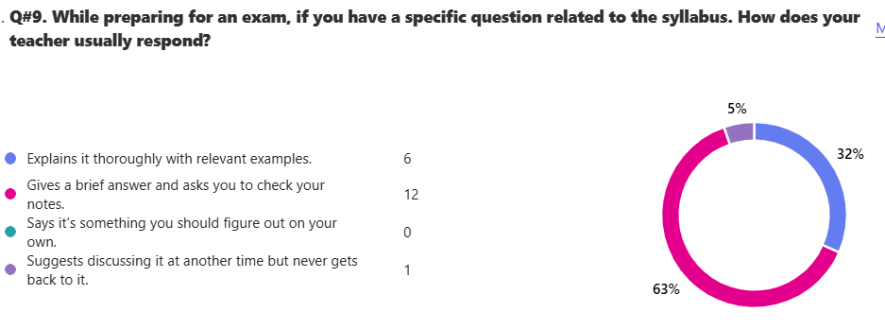

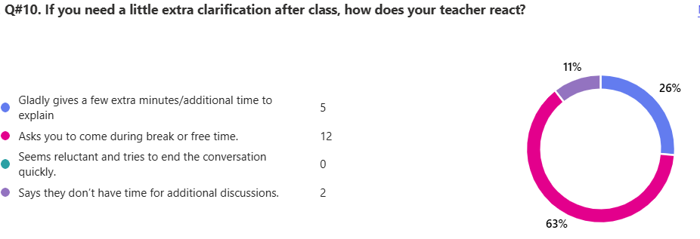

13. Any feedback that you would like to share with Board of Directors.
10 responses
ID | Responses
1 | It is impudent to rank the teachers as I feel they are all doing their utmost best so, contradicting my ranking above, I feel all the teachers are really good are fully capable of teaching their respective subjects.
2 | more frequents assessments more club and extracurricular activities
3 | mam ghazal shariq is not good she really is not doing her best and mam nida is ok in studies but she is not good in talking to stydents
4 | allow phones for ig2 + we need more events
5 | projector dosent work properly
6 | Please try to allocate resources towards extracurricular activities, to avoid monotony and allow variety in our routines as simply studying all day with barely any extra activities dedicated to entertainment, destroys a students' will. Kindly work on better air conditioning facilities and sturdier seats, etc. Ensure better disciplinary check-ups during time between classes.
7 | Aoa sir how are you, I would like to ask if you could please send the marking scheme of papers to the students after for example assessments or midterms aswell as regular class tests, as sometimes the marking is done unfairly
8 | the school is pretty good however it could be improved. The photocopier is very inconsistent and it takes almost 2 days to get a workbook alongside some of the projectors were malfunctioning and this could be improved further
9 | AOA Sir, hope you're doing well i would like to ask you to please share the mark schemes for assessments as well as the mids and the upcoming Mock practices for Pak Studies ,Islamiat, and Urdu . Thank you very much.
10 | none
IG-II Mercury - Boys
Total Reponses: 24
Q#1: Which teachers encourage you the most to ask questions about the topics being studied and are happy to answer them? *You may select as many options as you like.
Name | Responses | Percentage
Mr. Danayal Tariq - History | 16 | 15%
None of the above | 16 | 15%
Ms. Shugufta Adil - English | 15 | 14%
Ms. Saman Ali - Chemistry | 14 | 13%
Mr. Ali Javed - Physics | 12 | 11%
Mr. Irfan Sajjad Alvi - Islamiyat | 11 | 10%
Mr. Amir Saleem - Geography | 10 | 9%
Ms. Sehrish Abbas - Maths | 8 | 8%
Ms. Qudsia Shaheen - Urdu | 4 | 4%
Ms. Sadaf Abdullah - Biology | 0 | 0%

Q#2: Which teachers report late for the class? * (You may select as many options as you like.)*
Name | Responses | Percentage
Mr. Amir Saleem - Geography | 15 | 52%
None of the above | 7 | 24%
Mr. Irfan Sajjad Alvi - Islamiyat | 3 | 10%
Ms. Qudsia Shaheen - Urdu | 2 | 7%
Ms. Sehrish Abbas - Maths | 1 | 3%
Ms. Sadaf Abdullah - Biology | 1 | 3%
Ms. Shugufta Adil - English | 0 | 0%
Ms. Saman Ali - Chemistry | 0 | 0%
Mr. Ali Javed - Physics | 0 | 0%
Mr. Danayal Tariq - History | 0 | 0%

Q#3: Which teachers conclude their classes before the allotted time? * (You may select as many options as you like.)
Name | Responses | Percentage
None of the above | 14 | 27%
Ms. Sehrish Abbas - Maths | 6 | 12%
Ms. Saman Ali - Chemistry | 5 | 10%
Ms. Shugufta Adil - English | 4 | 8%
Ms. Qudsia Shaheen - Urdu | 4 | 8%
Ms. Sadaf Abdullah - Biology | 4 | 8%
Mr. Ali Javed - Physics | 4 | 8%
Mr. Amir Saleem - Geography | 4 | 8%
Mr. Irfan Sajjad Alvi - Islamiyat | 3 | 6%
Mr. Danayal Tariq - History | 3 | 6%

Q#4: Which teachers indulge in irrelevant discussions. * (You may select as many options as you like.)
Name | Responses | Percentage
None of the above | 12 | 43%
Mr. Ali Javed - Physics | 6 | 21%
Mr. Irfan Sajjad Alvi - Islamiyat | 4 | 14%
Mr. Amir Saleem - Geography | 3 | 11%
Ms. Sehrish Abbas - Maths | 2 | 7%
Ms. Qudsia Shaheen - Urdu | 1 | 4%
Ms. Shugufta Adil - English | 0 | 0%
Ms. Saman Ali - Chemistry | 0 | 0%
Ms. Sadaf Abdullah - Biology | 0 | 0%
Mr. Danayal Tariq - History | 0 | 0%

Q#5: Which teachers use cell phones in their classes? * (You may select as many options as you like.)
Name | Responses | Percentage
None of the above | 13 | 48%
Mr. Danayal Tariq - History | 7 | 26%
Mr. Amir Saleem - Geography | 3 | 11%
Ms. Qudsia Shaheen - Urdu | 2 | 7%
Ms. Sehrish Abbas - Maths | 1 | 4%
Mr. Irfan Sajjad Alvi - Islamiyat | 1 | 4%
Ms. Shugufta Adil - English | 0 | 0%
Ms. Saman Ali - Chemistry | 0 | 0%
Ms. Sadaf Abdullah - Biology | 0 | 0%
Mr. Ali Javed - Physics | 0 | 0%

Q#6. Which teacher asks you to take paid tuition from him/her in the evening to get an A* or a good grade?
Name | Responses | Percentage
None of the above | 15 | 63%
Mr. Amir Saleem - Geography | 5 | 21%
Mr. Danayal Tariq - History | 2 | 8%
Ms. Qudsia Shaheen - Urdu | 1 | 4%
Ms. Sehrish Abbas - Maths | 1 | 4%
Ms. Shugufta Adil - English | 0 | 0%
Ms. Saman Ali - Chemistry | 0 | 0%
Ms. Sadaf Abdullah - Biology | 0 | 0%
Mr. Ali Javed - Physics | 0 | 0%
Mr. Irfan Sajjad Alvi - Islamiyat | 0 | 0%

Q#7. Which subject do you find most challenging?
Name | Responses | Percentage
Ms. Saman Ali - Chemistry | 14 | 33%
Ms. Sehrish Abbas - Maths | 7 | 17%
Mr. Ali Javed - Physics | 5 | 12%
Mr. Danayal Tariq - History | 5 | 12%
Ms. Qudsia Shaheen - Urdu | 4 | 10%
Mr. Amir Saleem - Geography | 4 | 10%
Ms. Sadaf Abdullah - Biology | 2 | 5%
Ms. Shugufta Adil - English | 1 | 2%
Mr. Irfan Sajjad Alvi - Islamiyat | 0 | 0%
None of the above | 0 | 0%

Q#8. How would you rate the teacher’s overall performance?
Name | Ranking
Ms. Shugufta Adil - English | 1
Ms. Sadaf Abdullah - Biology | 2
Mr. Ali Javed - Physics | 3
Mr. Danayal Tariq - History | 4
Ms. Saman Ali - Chemistry | 5
Mr. Irfan Sajjad Alvi - Islamiyat | 6
Ms. Qudsia Shaheen - Urdu | 7
Ms. Sehrish Abbas - Maths | 8
Mr. Amir Saleem - Geography | 9

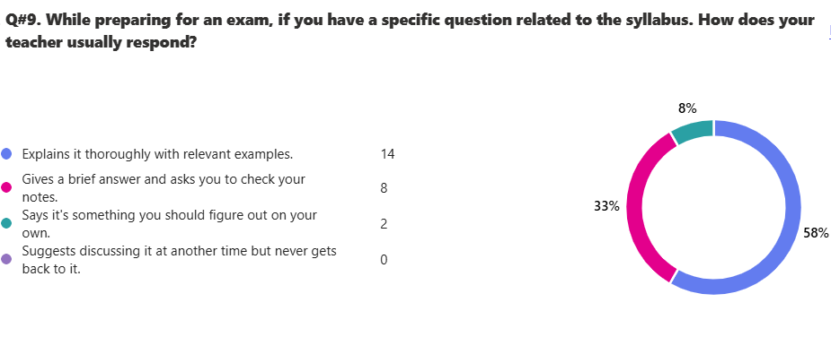
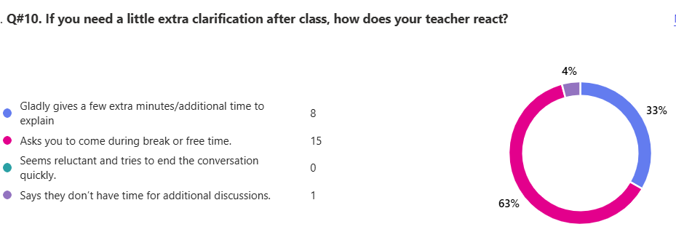

13. Any feedback that you would like to share with Board of Directors.
15 responses

ID | Responses
1 | Please Kindly Add More Extra Curriculars
2 | All Teachers are Great!
3 | The education is great but there is very less space for sports
4 | The education is great but there is very less space for sports
5 | No
6 | nothing........
7 | The education is great but there is very less space for sports
8 | overall the teachers are cooperative
9 | Ms. Sehrish usually doesn't respond to questions with clear answers, rather does it herself without explaining.
10 | Ahmed Saaed and Taimor asad are very trouble causing and need to get in line they make fun of kids and make vulgar jokes.
11 | I think Mam sehrish should learn to control the class because some specific boys in the class dont let others understand the topic and this is very frequent in Maths/Mam sehrish's class
12 | EVERY THING IS PERFECT
13 | AL TEACHERS ARE REALLY GOOD
14 | Islamist and geography teacher discuss some irrelevant things that aren't part of the topic
15 | Respected sir, Mam qudsia scolds' students without any reason.

IG-II Pluto - Boys
Total Reponses: 14
Q#1: Which teachers encourage you the most to ask questions about the topics being studied and are happy to answer them? *You may select as many options as you like.
Name | Responses | Percentage
Mr. Khawaja Zahid Hussain - Geography | 11 | 20%
Ms. Farah Imran - History | 10 | 18%
Mr. M. Taha Zaidi - Accounting | 9 | 16%
Mr. Kamran Yousaf - Business Studies | 9 | 16%
Ms. Shougufta Adil - English | 5 | 9%
Mr. Tariq Mehmood - Economics | 5 | 9%
Mr. Zubair Nazeer - Maths | 4 | 7%
Ms. Shazia Lasari - Urdu | 2 | 4%
Ms. Rubina Akhtar - Islamiayt | 1 | 2%
None of the above | 0 | 0%

Q#2: Which teachers report late for the class? * (You may select as many options as you like.)*
Name | Responses | Percentage
Mr. Kamran Yousaf - Business Studies | 6 | 32%
None of the above | 6 | 32%
Ms. Shazia Lasari - Urdu | 2 | 11%
Ms. Rubina Akhtar - Islamiayt | 2 | 11%
Ms. Shougufta Adil - English | 1 | 5%
Mr. Khawaja Zahid Hussain - Geography | 1 | 5%
Ms. Farah Imran - History | 1 | 5%
Mr. Zubair Nazeer - Maths | 0 | 0%
Mr. M. Taha Zaidi - Accounting | 0 | 0%
Mr. Tariq Mehmood - Economics | 0 | 0%

Q#3: Which teachers conclude their classes before the allotted time? * (You may select as many options as you like.)
Name | Responses | Percentage
None of the above | 7 | 41%
Ms. Rubina Akhtar - Islamiayt | 3 | 18%
Ms. Shougufta Adil - English | 2 | 12%
Ms. Shazia Lasari - Urdu | 2 | 12%
Mr. M. Taha Zaidi - Accounting | 2 | 12%
Mr. Kamran Yousaf - Business Studies | 1 | 6%
Mr. Zubair Nazeer - Maths | 0 | 0%
Mr. Tariq Mehmood - Economics | 0 | 0%
Mr. Khawaja Zahid Hussain - Geography | 0 | 0%
Ms. Farah Imran - History | 0 | 0%

Q#4: Which teachers indulge in irrelevant discussions. * (You may select as many options as you like.)
Name | Responses | Percentage
Mr. Kamran Yousaf - Business Studies | 5 | 24%
Ms. Shazia Lasari - Urdu | 4 | 19%
None of the above | 4 | 19%
Ms. Rubina Akhtar - Islamiayt | 3 | 14%
Ms. Shougufta Adil - English | 2 | 10%
Mr. Zubair Nazeer - Maths | 2 | 10%
Mr. Tariq Mehmood - Economics | 1 | 5%
Mr. M. Taha Zaidi - Accounting | 0 | 0%
Mr. Khawaja Zahid Hussain - Geography | 0 | 0%
Ms. Farah Imran - History | 0 | 0%

Q#5: Which teachers use cell phones in their classes? * (You may select as many options as you like.)
Name | Responses | Percentage
None of the above | 7 | 39%
Ms. Shougufta Adil - English | 3 | 17%
Ms. Shazia Lasari - Urdu | 3 | 17%
Mr. Kamran Yousaf - Business Studies | 2 | 11%
Mr. M. Taha Zaidi - Accounting | 1 | 6%
Mr. Tariq Mehmood - Economics | 1 | 6%
Ms. Rubina Akhtar - Islamiayt | 1 | 6%
Mr. Zubair Nazeer - Maths | 0 | 0%
Mr. Khawaja Zahid Hussain - Geography | 0 | 0%
Ms. Farah Imran - History | 0 | 0%

Q#6. Which teacher asks you to take paid tuition from him/her in the evening to get an A* or a good grade?
Name | Responses | Percentage
None of the above | 9 | 64%
Ms. Shazia Lasari - Urdu | 2 | 14%
Mr. Kamran Yousaf - Business Studies | 2 | 14%
Mr. M. Taha Zaidi - Accounting | 1 | 7%
Ms. Shougufta Adil - English | 0 | 0%
Mr. Zubair Nazeer - Maths | 0 | 0%
Mr. Tariq Mehmood - Economics | 0 | 0%
Ms. Rubina Akhtar - Islamiayt | 0 | 0%
Mr. Khawaja Zahid Hussain - Geography | 0 | 0%
Ms. Farah Imran - History | 0 | 0%

Q#7. Which subject do you find most challenging?
Name | Responses | Percentage
Mr. Zubair Nazeer - Maths | 9 | 26%
Mr. M. Taha Zaidi - Accounting | 8 | 24%
Mr. Tariq Mehmood - Economics | 5 | 15%
Ms. Rubina Akhtar - Islamiayt | 4 | 12%
Ms. Farah Imran - History | 3 | 9%
Ms. Shougufta Adil - English | 2 | 6%
Ms. Shazia Lasari - Urdu | 2 | 6%
Mr. Kamran Yousaf - Business Studies | 1 | 3%
Mr. Khawaja Zahid Hussain - Geography | 0 | 0%
None of the above | 0 | 0%

Q#8. How would you rate the teacher’s overall performance?
Name | Ranking
Ms. Farah Imran - History | 1
Mr. Khawaja Zahid Hussain - Geography | 2
Mr. Kamran Yousaf - Business Studies | 3
Ms. Shougufta Adil - English | 4
Mr. M. Taha Zaidi - Accounting | 5
Mr. Tariq Mehmood - Economics | 6
Ms. Shazia Lasari - Urdu | 7
Mr. Zubair Nazeer - Maths | 8
Ms. Rubina Akhtar - Islamiayt | 9

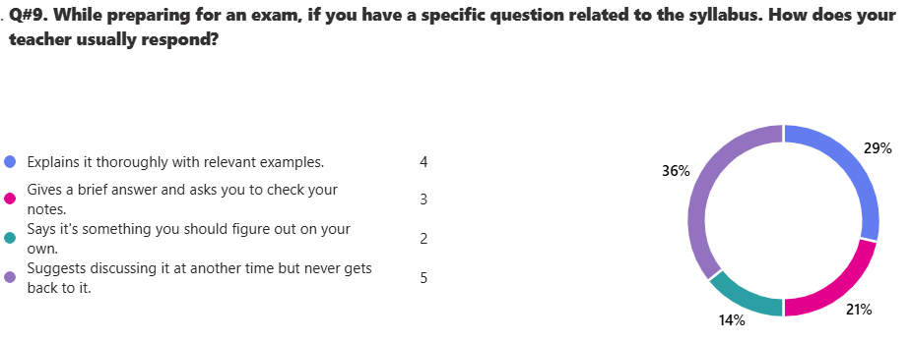

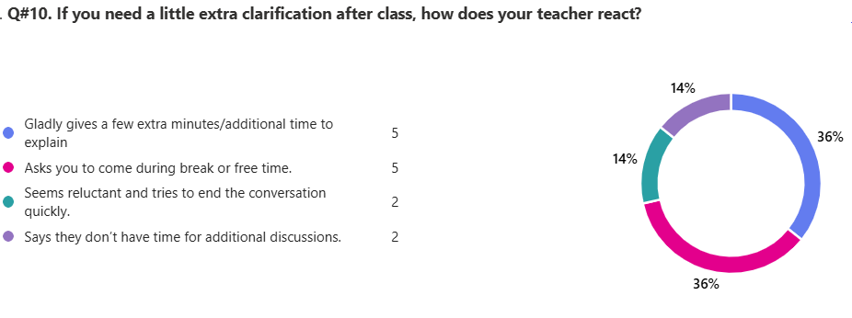
13. Any feedback that you would like to share with Board of Directors.
14 responses

ID | Responses
1 | I don't want any Bullies and students who don't cooperate with teachers please give them either time to change themselves or suspend them.
2 | HI THE BOARD OF DIRECTORS I WOULD LIKE TO SUGGEST THAT YOU SHOULD CHANGE OUR MATHS TEACHRER , WE CANT UNDERSTAND THEM AND NONE OF THE CLASS LISTENS TO HIM , WE FIND HIS CLASS A BIT BORING ,
3 | All the teachers are passionate to their job, and they convey their subjects in a good way. Sports activities are not focused that much or are mismanaged this should be brought into focus.
4 | i do not have any further problems
5 | replace current account eco and business teachers with previous ig 1 teachers
6 | dont have any feedback thanks
7 | the urdu teacher talks aboout politics in class and other highly contreversial topics and i dont like it she talked abt a childs aunt who is maryam aurengazeb and said she has a plastic face.she also screams when smone asks a question.the english maam should be replaced with maam hazbeela
8 | pleasegive us our business teacher mam inshal back the class is not able to under stand sir kamran the urdu teacher also talk about politics in the class as my family is in politics she targets me just a simple request please send our business teacher back
9 | I would like to share my feedback about mam Rubina khan. She doesn't take questions and her pattern to teach us is like she is studying by herself. She just ignores any of our questions saying blatantly that we ask useless questions, though they are related to the syllabus. She just comes to the class, opens her notes and just reads them. I would also like to explain about Sir Zubair. Though he teaches kind of well, I think there are better teachers available, as sometimes the concept is kind of not clear since we only get 3 periods of math's in a week and 2 of them are short periods on Friday. So, Sir Zubair is mostly in a hurry, and we usually don't get the concept.
10 | I personally think that sir Kamran Yousaf is rude during the class and insults children which ruins the decorum of class and makes his students feel de motivated. and the over all class has very less understanding of sir Tariq Mehmood in economics , it does not feel like an energetic class. the Urdu teacher usually debates with kids on cultural talks which is not part of our class. in first few days I thought sir taha Mehmood was also bad but he's a pretty good teacher over all. I also highly request the admins to switch sir Tariq Mehmood to sir Saqib in economics thankyou.
11 | charity for people who are suffering from floods also conduct the quran translation class earth quake and emergency drills kindly change the islamaiat teacher also change the
12 | I think that sir kamran yousaf needs to be serious in the class as he always talks about irrelevant discussions and whenever a student ask a question he does not reply and instead makes fun of him. One more thing is that sir tariq mehmood needs to be replaced with sir saqib tariq as he is not corrperate with students. thank you
13 | Our Maths sir is not able to control the class and also i am not able to understand his style of teachingB Bring maam Inshal back.
14 | I want our economics sir Tariq Mehmood to be replaced with mam Inshaal Noor, our math's sir 'Zubair Nazeer' should also be replaced with mam Sania Naveed. I also want our English teacher Mam Shagufta Adil to be replaced with Mam Hazbeela if possible, and our Islamiyat teach 'Mam Robina' with sir Irfan Alvi.

IG-II Earth - Boys
Total Reponses: 23
Q#1: Which teachers encourage you the most to ask questions about the topics being studied and are happy to answer them? *You may select as many options as you like.
Name | Responses | Percentage
Mr. Ali Javed - Physics | 11 | 14%
Ms. Farah Imran - Geography | 11 | 14%
Mr. Mohsin Saleem – Chemistry | 10 | 13%
Ms. Bushra Abbas - English | 9 | 12%
Ms. Sania Naveed - Maths | 9 | 12%
Mr. Mirza M. Asim - Computer Science | 9 | 12%
Ms. Samira Afzal - History | 8 | 10%
Mr. Irfan Sajjad Alvi - Islamiyat | 7 | 9%
Mr. Muhammad Bilal - Urdu | 3 | 4%
None of the above | 0 | 0%

Q#2: Which teachers report late for the class? * (You may select as many options as you like.)*
Name | Responses | Percentage
Ms. Bushra Abbas - English | 14 | 56%
None of the above | 7 | 28%
Mr. Muhammad Bilal - Urdu | 1 | 4%
Ms. Sania Naveed - Maths | 1 | 4%
Mr. Mirza M. Asim - Computer Science | 1 | 4%
Mr. Ali Javed - Physics | 1 | 4%
Mr. Mohsin Saleem – Chemistry | 0 | 0%
Mr. Irfan Sajjad Alvi - Islamiyat | 0 | 0%
Ms. Farah Imran - Geography | 0 | 0%
Ms. Samra Afzal - History | 0 | 0%

Q#3: Which teachers conclude their classes before the allotted time? * (You may select as many options as you like.)
Name | Responses | Percentage
None of the above | 11 | 33%
Mr. Ali Javed - Physics | 6 | 18%
Mr. Muhammad Bilal - Urdu | 5 | 15%
Ms. Sania Naveed - Maths | 3 | 9%
Mr. Irfan Sajjad Alvi - Islamiyat | 2 | 6%
Ms. Farah Imran - Geography | 2 | 6%
Ms. Bushra Abbas - English | 1 | 3%
Mr. Mohsin Saleem – Chemistry | 1 | 3%
Mr. Mirza M. Asim - Computer Science | 1 | 3%
Ms. Samra Afzal - History | 1 | 3%

Q#4: Which teachers indulge in irrelevant discussions. * (You may select as many options as you like.)
Name | Responses | Percentage
None of the above | 7 | 20%
Mr. Muhammad Bilal - Urdu | 6 | 17%
Mr. Ali Javed - Physics | 6 | 17%
Mr. Irfan Sajjad Alvi - Islamiyat | 5 | 14%
Ms. Bushra Abbas - English | 4 | 11%
Mr. Mirza M. Asim - Computer Science | 4 | 11%
Mr. Mohsin Saleem – Chemistry | 3 | 9%
Ms. Sania Naveed - Maths | 0 | 0%
Ms. Farah Imran - Geography | 0 | 0%
Ms. Samra Afzal - History | 0 | 0%

Q#5: Which teachers use cell phones in their classes? * (You may select as many options as you like.)
Name | Responses | Percentage
None of the above | 17 | 74%
Mr. Muhammad Bilal - Urdu | 4 | 17%
Mr. Mirza M. Asim - Computer Science | 2 | 9%
Ms. Bushra Abbas - English | 0 | 0%
Ms. Sania Naveed - Maths | 0 | 0%
Mr. Mohsin Saleem – Chemistry | 0 | 0%
Mr. Ali Javed - Physics | 0 | 0%
Mr. Irfan Sajjad Alvi - Islamiyat | 0 | 0%
Ms. Farah Imran - Geography | 0 | 0%
Ms. Samra Afzal - History | 0 | 0%

Q#6. Which teacher asks you to take paid tuition from him/her in the evening to get an A* or a good grade?
Name | Responses | Percentage
None of the above | 20 | 87%
Mr. Muhammad Bilal - Urdu | 2 | 9%
Mr. Mohsin Saleem – Chemistry | 1 | 4%
Ms. Bushra Abbas - English | 0 | 0%
Ms. Sania Naveed - Maths | 0 | 0%
Mr. Mirza M. Asim - Computer Science | 0 | 0%
Mr. Ali Javed - Physics | 0 | 0%
Mr. Irfan Sajjad Alvi - Islamiyat | 0 | 0%
Ms. Farah Imran - Geography | 0 | 0%
Ms. Samra Afzal - History | 0 | 0%

Q#7. Which subject do you find most challenging?
Name | Responses | Percentage
Mr. Mohsin Saleem – Chemistry | 16 | 43%
Mr. Muhammad Bilal - Urdu | 9 | 24%
Ms. Samra Afzal - History | 5 | 14%
Ms. Bushra Abbas - English | 4 | 11%
Mr. Mirza M. Asim - Computer Science | 1 | 3%
Mr. Irfan Sajjad Alvi - Islamiyat | 1 | 3%
Ms. Farah Imran - Geography | 1 | 3%
Ms. Sania Naveed - Maths | 0 | 0%
Mr. Ali Javed - Physics | 0 | 0%
None of the above | 0 | 0%

Q#8. How would you rate the teacher’s overall performance?
Name | Ranking
Mr. Ali Javed - Physics | 1
Mr. Mirza M. Asim - Computer Science | 2
Mr. Irfan Sajjad Alvi - Islamiyat | 3
Ms. Farah Imran - Geography | 4
Ms. Sania Naveed - Maths | 5
Mr. Mohsin Saleem – Chemistry | 6
Ms. Bushra Abbas - English | 7
Ms. Samra Afzal - History | 8
Mr. Muhammad Bilal - Urdu | 9

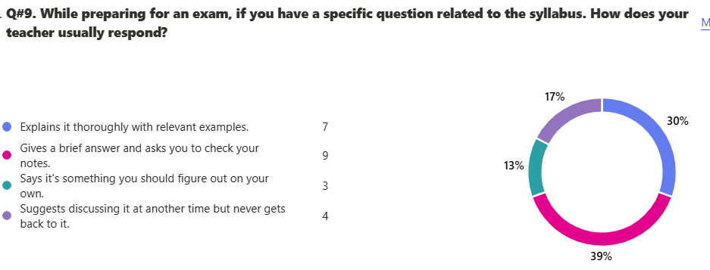

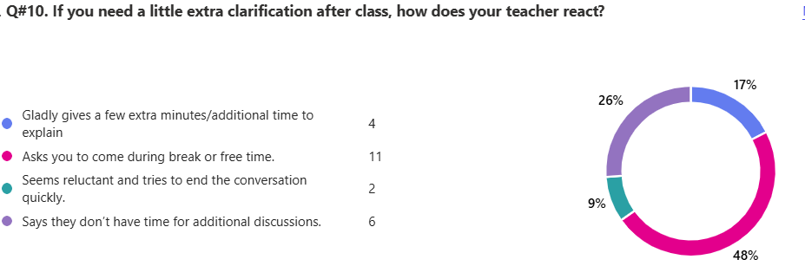

13. Any feedback that you would like to share with Board of Directors.
21 responses

ID | Responses
1 | :/
2 | This isn't going to be read anyways.
3 | 1:campus should be like normal schools
4 | More ground period because 1 isn't enough
5 | Please remove sir bilal as our urdu teacher because i dont understand anything in his class and that h fails me in every test or monthly assessment or an exam he doesnt even complete his work of urdu listening paper overall all the teachers are great
6 | Kindly tell Sir Bilal to not scream at children and be a little more friendly.
7 | I think that teachers should know how to keep the new generation a bit more engaged in whatever they are trying to teach.
8 | there should be more extra curricular activities and more focus towards sports especially basketball which would be a great addition to the supernova champions cup (sncc). And there should more games classes. Academics wise this school is very good compared to my previous school
9 | Please change our timetable because we don't have football ground on any of the days. Also replace our Urdu and English teacher.
10 | remove sir bilal please andd english teacher they are creepy
11 | we would prefer more games periods as our current schedule only allows us access to games only once a week.
12 | Most of the teachers at SuperNova tend to lack care for the conceptual understanding of the students and pay little attention to teaching mainly concerned with ensuring that students copy their notes that have been written by them which in my opinion is an ineffective method for teaching.
13 | Need Urdu teacher able to control the class, as there is a lot of disturbance. Need another printer as it takes lots of time there and he is pretty slow. Please, if possible, arrange another printer too. In Regards
14 | The biggest issue that i am having is that we have only 1 games period in our break which is on Monday we need more games period of around 3 to 4 ground periods. another thing is that we need 2 free periods a day to relax and refresh our minds. Please acknowledge my feedback. regards.
15 | The only problem i face is that our break schedule has only 1 games the entire week so i would like if we have a better timetable so we could in enjoy secondly we need atleast 2 free classes to refresh our minds. kind regards
16 | first we should be granted with atleast 3 games in week. Secondly our english teacher should be replaced with a better teacher because she dont explain the concept. lastly we need 1 free period to fresh our mind because it gets so frustating if there are consecative classes. kind regards
17 | The English teacher always comes late to class I don't think I have ever seen he come on time, she also made a rasist comment on one of my class fellows she said "go back to your world". Computer teacher does good explanation, but I don't understand his notes also give Sir Asim new camping gear. Math's teacher makes jokes but they're not funny, also whenever I ask any question she replies in an angry manner. Urdu teacher Mohammad Bilal is the BEST teacher he has perfect explanation, and I don't even have to ask a question because of how great he is he SHOULD get a RAIS. Geography teacher is a very good teacher. Physics sir does targeting to some students
18 | You should change sir bilal as he is not a good teacher waste alot of class time ,talk irrelevant in the class he screams at everyone without any reason it is an humble request to change him because we have to give our exam this year . He waste much class time he does not pay much attention on yhe students. He does not make us complete our classwork rest of the teachers are good and explains well
19 | Sir Mohsin Saleem takes extra time in useless talks and waste time instead of teaching us. Moreover, Sir Bilal does not take responsibility, children in class are bullying each other and he doesn't seem bothered at all instead he tells the victim of bullying to go outside the class. Sir Bilal also involves in useless talks, and we have barely learned anything since IG-1 and this year we also have to give our Urdu exam. Furthermore, he doesn't let us ask question regarding the topic we are studying, he says to asks question at the end of the lesson, but the fact is there is barely anytime left in the class to end. The timetable is also a bit frustrating for us as the break is in 4th period, after which there are consecutive classes which is exhausting for us. In my opinion the break should be in 5th period which is much better for the class. Our classes ac's wing is also broken which causes only one part of the class to get cold while the rest is extremely hot. So, it should be fixed as soon as soon as possible. Moreover, Our Urdu teacher doesn't make us do past papers and rely on his own made papers which is not authentic and also. He also doesn't make us do listening paper which is the core of our exam since IG-2 we have only done only a few listening papers. Please do take this review in account and do apply on my suggestions.
20 | Sir Mohsin Saleem involves himself in useless information instead of clarifying the topics we are studying. Sir Bilal does not take responsibility, children in the class are bullying each other while he does not take responsibility. He tells the bullied to get out of the class. he also talks about nonsensical things instead of engaging with us as students. We have learnt barely anything since I-G1, we are about to take our Urdu exam with no preparation because of him, whenever we have questions, he withholds them until the end in which there is no time left, and our queries remain unresolved. He also makes us do his repetitive past papers and does not rely on real past papers that will actually help during the exam. He barely does listening paper practice and when he does, he uses a small speaker with barely any volume. The timetable for I-G2 Earth should be changed as there is only one break which aligns with football; therefore, it is a request if you could change the timetable as the students who play football regularly are not seen by the coaches thus are not selected in the team. Also, our early breaks mean that we feel extremely tired after 4 or 5 consecutive classes afterwards. The AC in our room is pointed at 2 seats which become uninhabitable while the rest of the class is unbearably hot
21 | Sir bilal does not put alot of effort while teaching and does not complete class work like in listening paper we rarely do the 3rd and 4th exercises . There are more work that sir bilal doesnt make us complete and never gets back to it. Moreover he also wastes alot of class time . Rest are good teachers. But more tests should be taken by islamiat teacher as he has taken only one test and i believe he should take more tests as our papers are close . Moreover sir bilal always talking about taking test on a day but even on our reminder he never takes it. other sciences teachers take some test but i believe it is ok as we dont have papers of then this year . so urdu and isl sir should focus more on test especially sir irfan as isl is a lenghty subject. in conclusion sir bilial should complete classwork , not waste time, and take tests and sir irfan should take more tests

IG-II Jupiter - Boys
Total Reponses: 19
Q#1: Which teachers encourage you the most to ask questions about the topics being studied and are happy to answer them? *You may select as many options as you like.
Name | Responses | Percentage
Mr. Ghaus Muhammad - Computer Science | 15 | 21%
Ms. Durdana Sami - History | 12 | 16%
Mr. Mohsin Saleem – Chemistry | 11 | 15%
Mr. Habib ur Rehman - Islamiyat | 9 | 12%
Ms. Sehrish Abbasi - Maths | 7 | 10%
Mr. Danyal Tariq- Geography | 7 | 10%
Mr. Kamran Rasheed - Physics | 6 | 8%
Ms. Shugufta Adil - English | 5 | 7%
Mr. Muhammmad Bilal - Urdu | 1 | 1%
None of the above | 0 | 0%

Q#2: Which teachers report late for the class? * (You may select as many options as you like.)*

Name | Responses | Percentage
None of the above | 8 | 30%
Mr. Kamran Rasheed - Physics | 6 | 22%
Mr. Muhammmad Bilal - Urdu | 3 | 11%
Ms. Shugufta Adil - English | 2 | 7%
Ms. Sehrish Abbasi - Maths | 2 | 7%
Mr. Habib ur Rehman - Islamiyat | 2 | 7%
Mr. Mohsin Saleem – Chemistry | 1 | 4%
Mr. Ghaus Muhammad - Computer Science | 1 | 4%
Mr. Danyal Tariq- Geography | 1 | 4%
Ms. Durdana Sami - History | 1 | 4%

Q#3: Which teachers conclude their classes before the allotted time? * (You may select as many options as you like.)
Name | Responses | Percentage
Mr. Muhammmad Bilal - Urdu | 7 | 21%
Mr. Kamran Rasheed - Physics | 7 | 21%
None of the above | 7 | 21%
Ms. Sehrish Abbasi - Maths | 5 | 15%
Ms. Shugufta Adil - English | 3 | 9%
Mr. Mohsin Saleem – Chemistry | 1 | 3%
Mr. Ghaus Muhammad - Computer Science | 1 | 3%
Mr. Habib ur Rehman - Islamiyat | 1 | 3%
Mr. Danyal Tariq- Geography | 1 | 3%
Ms. Durdana Sami - History | 1 | 3%

Q#4: Which teachers indulge in irrelevant discussions. * (You may select as many options as you like.)
Name | Responses | Percentage
Ms. Shugufta Adil - English | 2 | %
Mr. Muhammmad Bilal - Urdu | 5 | %
Ms. Sehrish Abbasi - Maths | 2 | %
Mr. Mohsin Saleem – Chemistry | 0 | %
Mr. Ghaus Muhammad - Computer Science | 0 | %
Mr. Kamran Rasheed - Physics | 7 | %
Mr. Habib ur Rehman - Islamiyat | 0 | %
Mr. Danyal Tariq- Geography | 0 | %
Ms. Durdana Sami - History | 0 | %
None of the above | 9 | %

Q#5: Which teachers use cell phones in their classes? * (You may select as many options as you like.)
Name | Responses | Percentage
None of the above | 13 | 65%
Mr. Kamran Rasheed - Physics | 4 | 20%
Ms. Sehrish Abbasi - Maths | 2 | 10%
Mr. Muhammmad Bilal - Urdu | 1 | 5%
Ms. Shugufta Adil - English | 0 | 0%
Mr. Mohsin Saleem – Chemistry | 0 | 0%
Mr. Ghaus Muhammad - Computer Science | 0 | 0%
Mr. Habib ur Rehman - Islamiyat | 0 | 0%
Mr. Danyal Tariq- Geography | 0 | 0%
Ms. Durdana Sami - History | 0 | 0%

Q#6. Which teacher asks you to take paid tuition from him/her in the evening to get an A* or a good grade?
Name | Responses | Percentage
None of the above | 16 | 80%
Mr. Kamran Rasheed - Physics | 3 | 15%
Mr. Muhammmad Bilal - Urdu | 1 | 5%
Ms. Shugufta Adil - English | 0 | 0%
Ms. Sehrish Abbasi - Maths | 0 | 0%
Mr. Mohsin Saleem – Chemistry | 0 | 0%
Mr. Ghaus Muhammad - Computer Science | 0 | 0%
Mr. Habib ur Rehman - Islamiyat | 0 | 0%
Mr. Danyal Tariq- Geography | 0 | 0%
Ms. Durdana Sami - History | 0 | 0%

Q#7. Which subject do you find most challenging?
Name | Responses | Percentage
Mr. Kamran Rasheed - Physics | 9 | 28%
Mr. Mohsin Saleem – Chemistry | 7 | 22%
Mr. Muhammmad Bilal - Urdu | 4 | 13%
Ms. Shugufta Adil - English | 3 | 9%
Mr. Ghaus Muhammad - Computer Science | 3 | 9%
Ms. Durdana Sami - History | 3 | 9%
Mr. Habib ur Rehman - Islamiyat | 1 | 3%
Mr. Danyal Tariq- Geography | 1 | 3%
None of the above | 1 | 3%
Ms. Sehrish Abbasi - Maths | 0 | 0%

Q#8. How would you rate the teacher’s overall performance?
Name | Ranking
Ms. Durdana Sami - History | 1
Mr. Mohsin Saleem – Chemistry | 2
Mr. Habib ur Rehman - Islamiyat | 3
Mr. Danyal Tariq- Geography | 4
Mr. Ghaus Muhammad - Computer Science | 5
Ms. Sehrish Abbasi - Maths | 6
Mr. Muhammmad Bilal - Urdu | 7
Ms. Shugufta Adil - English | 8
Mr. Kamran Rasheed - Physics | 9

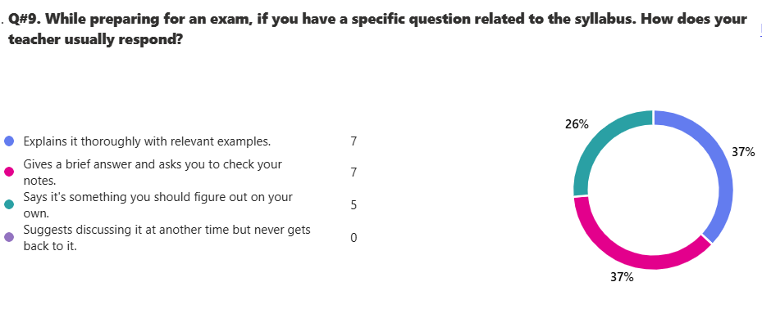

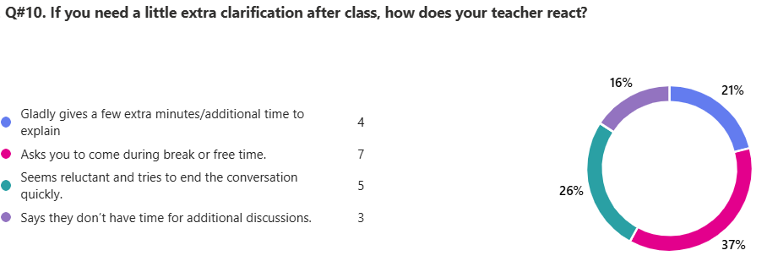

13. Any feedback that you would like to share with Board of Directors.
10 responses

ID | Responses
1 | Remove sir bilal
2 | we need a different physics teacher aswell as an urdu teacher because the urdu teacher cant control the class
3 | Please replace sir Kamran, and add more activities Aswell as improving football ground.
4 | more football for ig2 please and install turf on the roof and after school football for selected team members
5 | PLEASE!!! Replace Sir Kamran Rasheed and improve football ground facilities
6 | my feedback is to change the physics tteacher because he deesnot explain that well
7 | physics teacher aka sir kamran uses phone during the class and does double meaning talks which are very inappropriate with the students and also hit some students on head.Sir bilal doesnt let us ask them any questions and tells us to ask later but the class end till that.
8 | i am very scared of sir bilal hopefully he does not do my follow up and sir kamran is not a good teacher he just explains the topic briefly and he does not has any notes nor does he make us do past papers since the start and sir bilal does not listen to the students including me he says do it on your own and says phrases like am i not school and penpicture is being made and so he does not answer any questions and the class is completely rowdy is his lesson and maam durdana i sthe best teacher and the english teacher is actually pretty nice and knows everything which is really really helpful
9 | we should get games twice in a week we only get one games on friday in which we only get to play for 5 minutes. and teachers should take regular tests to see our performance
10 | the main problem is the behavior of the students sitting in this class, they have no serious attitude towards studying and don't let any other student study with focus, teacher good but most of their time is finished settling the students who are not serious.

